**CHRISTINE’S PERSONAL DIARY**

I’m Christine Daaé and I’m a singer at the Opera House in Paris. I have had a very hard life and now I’m going to explain my story.

I come from Sweden. My father is Mr Daaé and now he is dead. He was a very good violinist and he lived for his music. I love him and I miss him every day of my life. When I was a little girl, he taught me to sing. We used to go together from village to village, playing for the people. We had a very special relationship and he taught me everything I know.

One day, while I was singing with my father, a young boy came to hear us and he followed us until the sea. I didn’t know who he was, but I liked him. Suddenly, the wind blew my scarf into the sea. I was sad and this boy went running into the sea and brought it back to me. After that, we became friends. He was called Raoul.

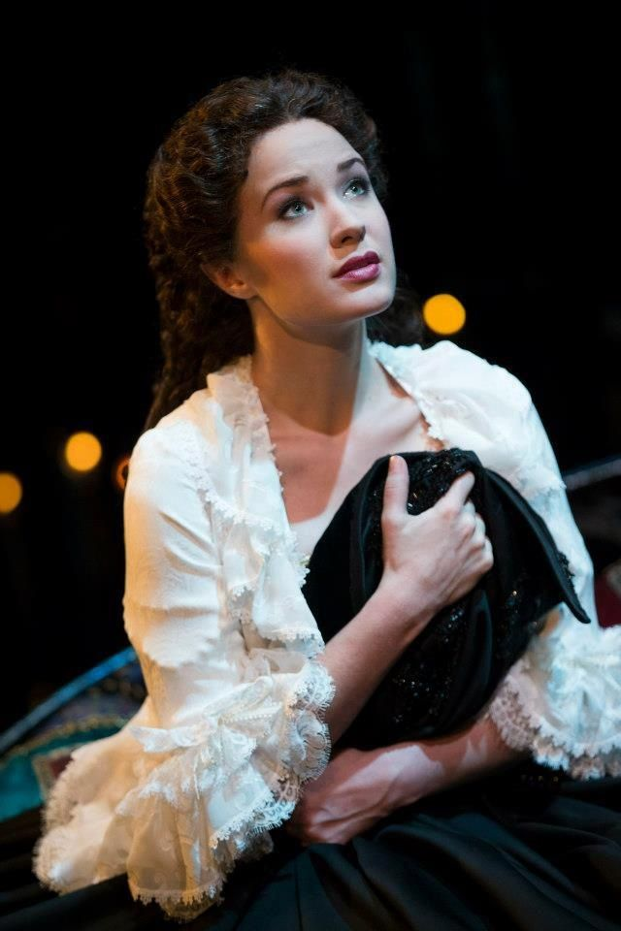My father liked Raoul and he taught him to play the violin. He also explained us stories. Almost every story he told us was about ghosts but one story I will always remember is the one about the Angel of Music. He explained us that anyone can sing or play well unless they hear the Angel of Music. But anyone has seen him, he used to tell us. He even promised me to send him to me when he had gone. I never thought of it again, until my father died.

After this, I was depressed, and my voice began to disappear slowly. Raoul disappeared too. I began to sing for the Opera House in Paris. My voice wasn’t very special, but I could earn some money by singing there. One day, I met the Angel of Music. He was called Erik. That day, I remembered my dad and his story, that now was true. Erik taught me to sig and my voice got a lot better. Everyone loves listening to me now. Everything was going on very well until I saw Raoul, the little boy who saved my scarf from the sea, in the Opera. We’ve fallen in love immediately, but I can’t be with him because I have to be loyal to Erik. If I leave with Raoul, Erik is going to kill the two of us! Now I must tell Raoul I don’t love him!